Table of Contents

- Polling
- Nonverbal Feedback
- Virtual Backgrounds
- Annotation
- Breakout Rooms
- Chat
- Guest Speakers
- Other Collaboration Tools

Polling: Zoom guide on Polling for Meetings
- Create your poll before you start the meeting
  - Visit Xavier.zoom.us
  - Open your scheduled meeting, or schedule a new one
  - Scroll to the bottom of the meeting management page and click Add under the Polls section
  - Add the title and any answer options you wish to provide
  - Click Save at the bottom
- Launch your poll in the meeting
  - Click Polls in the meeting controls.
  - Select the poll you would like to launch.
  - Click Launch Poll.
  - Once you would like to stop the poll, click End Poll.
  - If you would like to share the results to the participants in the meeting, click Share Results.
Nonverbal Feedback: Zoom guide on Providing Nonverbal Feedback during Meetings
- Click the Participants button.
- Click one of the icons to provide feedback to the host. Click the icon again to remove it.
  - Note: You can only have one icon active at a time.
  - Options Include:
    - Raise Hand / Lower Hand
    - yes
    - no
    - go slower
    - go faster
  - Additional icons are available by clicking the more button:
    - agree
    - disagree
    - clap
    - need a break
    - away
- The icon will appear next to your name in the participants list.
Virtual Backgrounds: Zoom guide on Virtual Background
- In a Zoom meeting click the ^ arrow next to Start/Stop Video.
- Click Choose a virtual background...
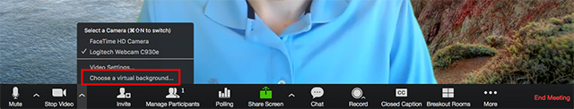
If prompted, click Download to download the package for virtual background without a green screen.
- After you select an option, that virtual background will display during your meetings.
- To disable Virtual Background, choose the option None.

Annotation: Zoom guide on Using annotation tools on a shared screen or whiteboard
- Accessing annotation tools if you started screen sharing
- After sharing your screen annotation controls will display.
- Accessing annotation tools if you are viewing a shared screen
- While viewing a shared screen or shared whiteboard, click View Options then Annotate at the top.
- Annotation tools
You will see these annotation tools:
  - The Select, Spotlight, and Save options are only available if you started the shared screen or whiteboard.
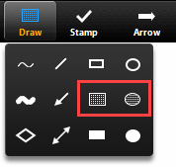
  - Highlight: To highlight an area of the shared screen or whiteboard, select following square or circle icon to insert a semi-transparent square or circle.

  - Spotlight (only available if you started the shared screen or whiteboard): Displays your mouse pointer to all participants when your mouse is within the area being shared. Use this to point out parts of the screen to other participants.
  - Arrow: Displays a small arrow instead of your mouse pointer. Click to insert an arrow that displays your name. Each subsequent click will remove the previous arrow placed. You can use this feature to point out your annotations to other participants.
  - Clear: Delete all annotations.
  - Save (only available if you started the shared screen or whiteboard): Save all annotations on the screen as a screenshot.

Breakout Rooms: Zoom guides on using Breakout Rooms:
- Participant in breakout rooms (participants)
- Manage breakout rooms (host)
- Pre-assign participants to breakout rooms (host)
Example Classroom Uses: You can use breakout rooms for small group discussions, peer review, or practice demonstrations.
Creating Breakout Rooms in a Zoom session:
- Click on “Breakout Rooms” from the Zoom control bar after clicking “More”
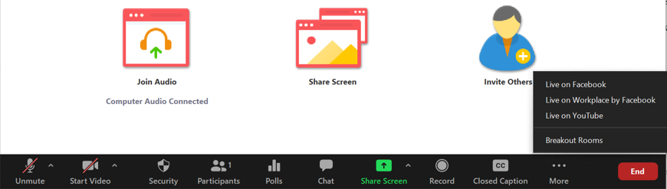
- Select how many Breakout Rooms you would like to create in the box that appears. You can either automatically assign students to the rooms, or manually add them.
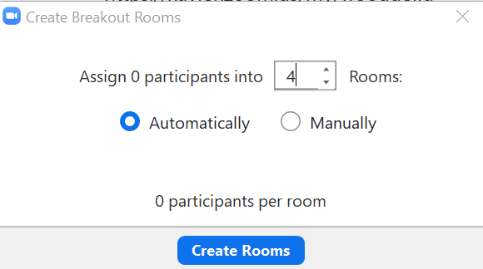
- If manually assigning the Breakout Rooms, click the Assign button beside each group to select the students/attendees to add to each group.
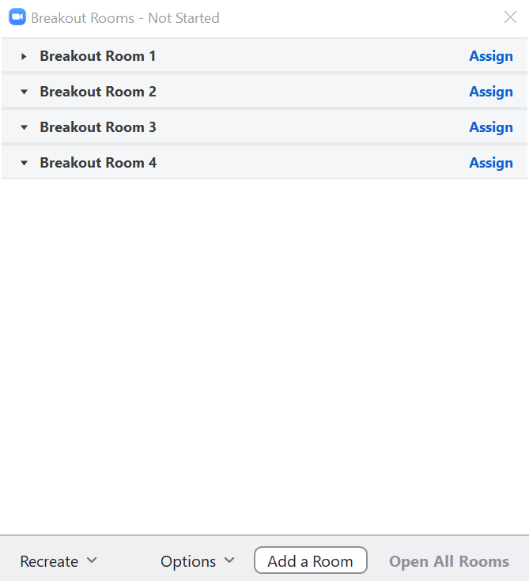
- You can also set additional options for the Breakout Rooms by clicking the “Options” button at the bottom. You can also add additional rooms by clicking the “Add a Room” button at the bottom.
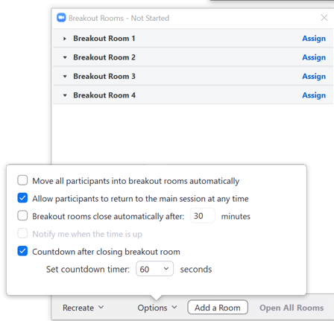
Viewing Breakout Rooms in a Zoom Session:
- Click on “Breakout Rooms” from the Zoom control bar after clicking “More”.
- If the breakout rooms are not open, click the “Open All Rooms” button at the bottom.
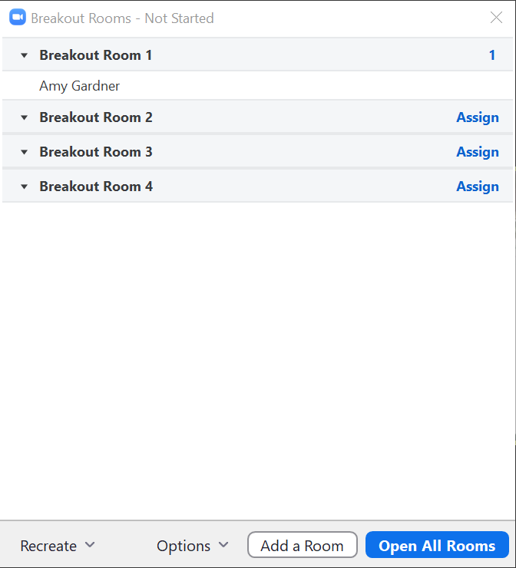
- Join a breakout room by clicking the “Join” button next to the room that you want to join, then click Yes when prompted to join.
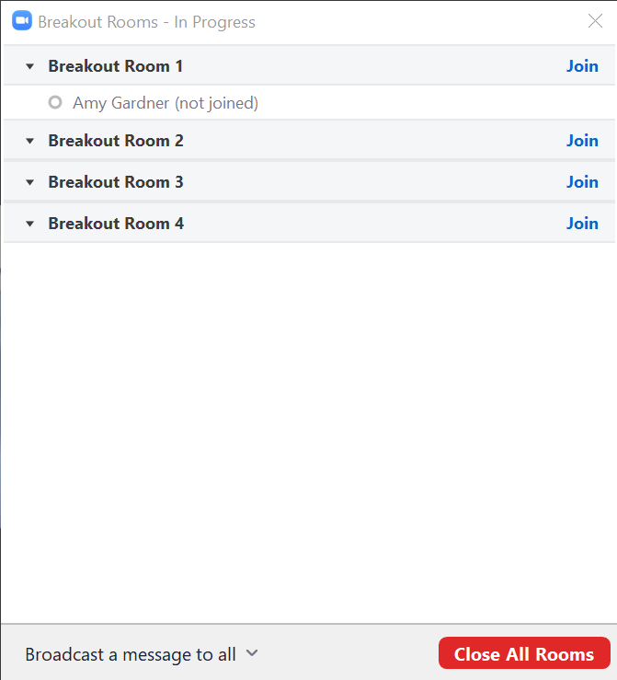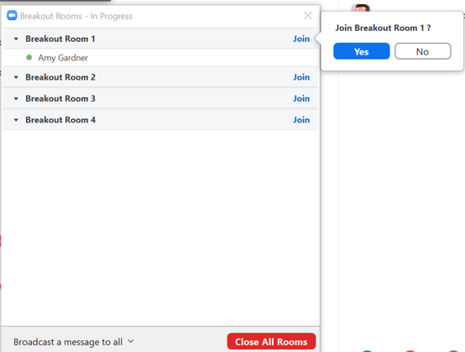

- The breakout room looks like the main Zoom room, and has most of the same features as the main room. As the host of the Zoom meeting, you can also broadcast a message to all of the breakout rooms by clicking on the “Breakout Rooms” button and then clicking on the “Broadcast a message to all” button at the bottom of that window.
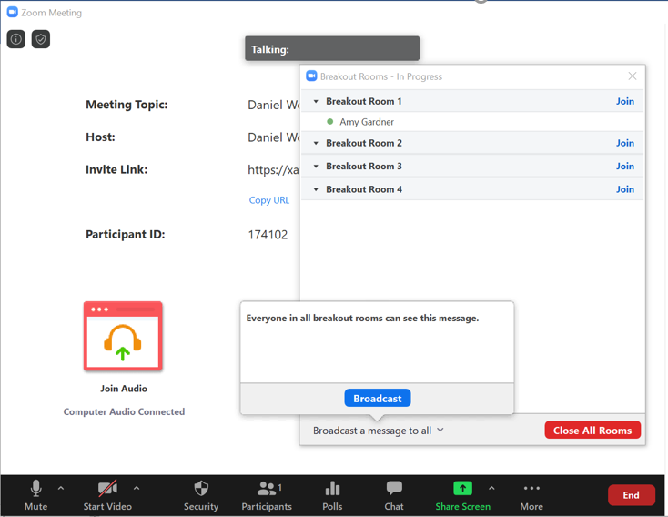
- To move to another breakout room, click on the “Breakout Rooms” button, and then click on the “Join” button beside the group that you would like to move to. You can also leave the breakout room altogether by clicking the “Leave” button. You and your students who click the Leave button will be taken back to the main meeting room.
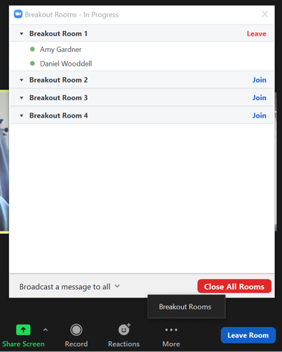
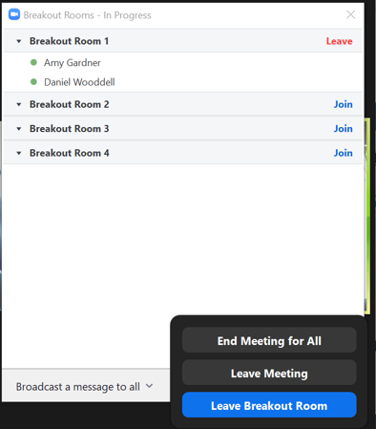

Chat: Zoom guide on using chat in meetings

Example Classroom Uses: Have students use the chat feature to ask questions or respond to your questions. You can also share documents or other files with the class that they can download through the chat area.
- While in a meeting, click on the “Chat” button in the meeting controls.
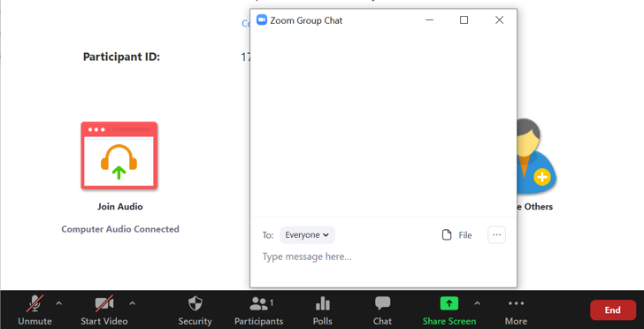
- This will open the chat in a pop-up box. You and your students can type a message into the chat box, or click on the drop down next to “To:” if you want to send a message to a specific attendee in the meeting.
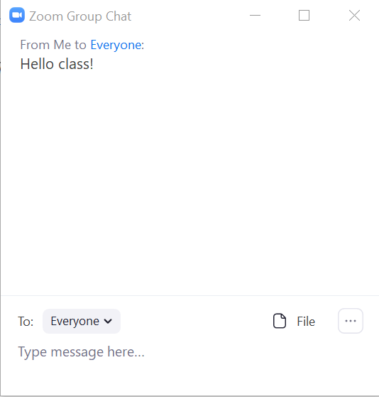
- You and your students can also save the chat by clicking the 3-dot menu in the chat window. Additional options for participant chat can also be set from that menu.
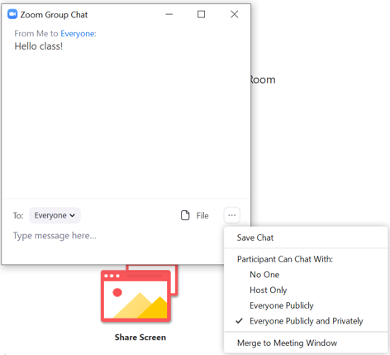
- You can share files with the attendees by clicking the “File” button in the chat window, and then selecting the file off of your computer/device.

Guest Speakers: Zoom guide on inviting others to join a meeting
Example Classroom Uses: Bring guest speakers into your live sessions to offer specialized expertise or an additional perspective.
- Invite the guest speaker into the meeting by clicking the “Invite Others” button in the middle of the Zoom window. (inviting can also be done when scheduling the meeting ahead of time)
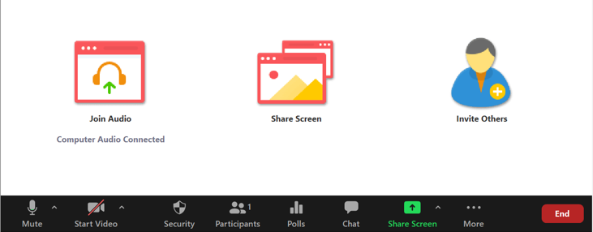
- Here you can copy the meeting invitation by clicking the button at the bottom-left corner of the window, or you could select the Email tab to open up your email program with the meeting invitation ready to send. Send the email to the guest speaker’s preferred email address.
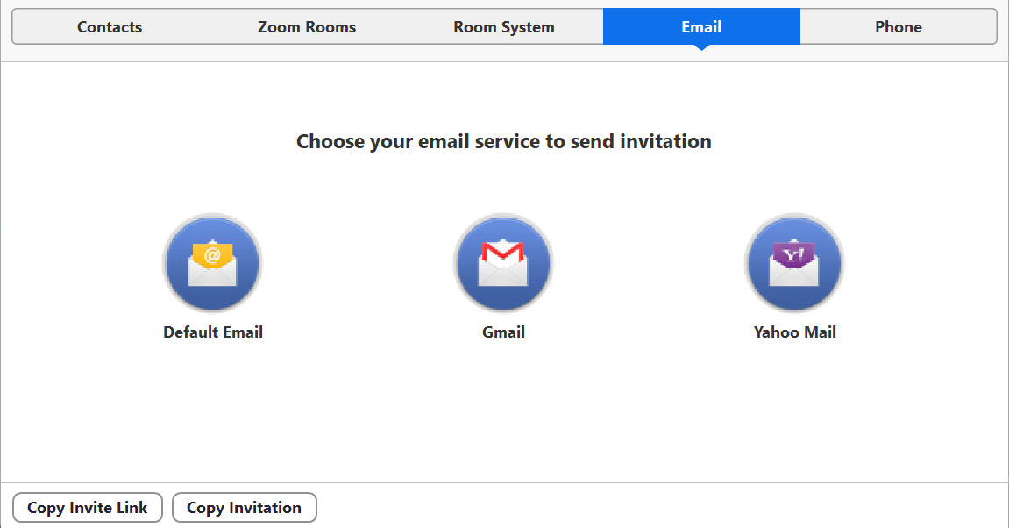
- Ensure that the participants in the meeting are able to share their screen if the guest speaker plans to present anything in the session. Simply click on the “Security” button at the bottom of Zoom and make sure that “Screen Share” is enabled.
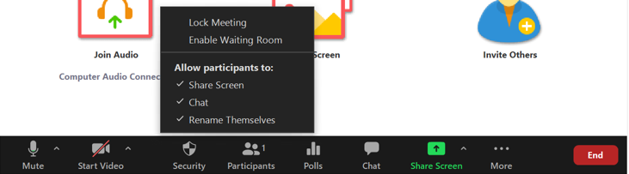

Incorporating other collaboration tools
Example Classroom Uses: Students could work on a shared Google Doc or Office 365 Doc with a provided link, share documents and other files with each other, contribute to a shared whiteboard, or collaborate on a group mindmap.
- Google Docs and Office 365 Docs: post the link to the shared document in the chat area of the meeting. Students could also create their own Google Doc or Office 365 Doc and share it in the meeting, or share it through Breakout Rooms.
- Sharing a document: you and your students can share a document (or other file) in the meeting through the chat area. Click on the “File” button there and select a file off of your device to share it with the class. This can also be done in Breakout Rooms.
- Shared whiteboard: using a free whiteboarding tool like Ziteboard, you and your students can collaborate on the shared whiteboard together in real time.
- Mindmapping tools: using a free mindmapping tool like Coggle, you and your students can share their mindmapping diagrams in chat with the public link to those. This can also be done in Breakout Rooms.

